PFL Color Logo No Tag Patten Free Library, Children's Room, 33 Summer St, Bath, ME 04530, 443-5141 x1016

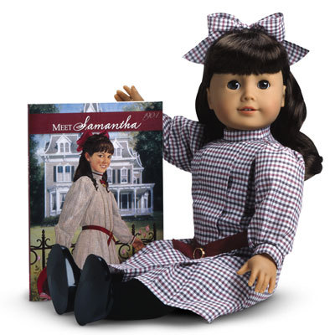

**Meet Samantha: The American Girl Doll** you can take home and return. Samantha Parkington has brown eyes and dark brown, wavy, bangs. Her hair is pulled into a half-ponytail in the back. Samantha opens up a whole world of imaginative play and comes with authentic styles from 1904.

**The kit includes:**

* 1 doll named Samantha *($100)
* 1 paperback book, *Meet Samantha* by Susan Adler, Jeanne Thieme and Dan Andreasen *($10)
* [Journal to record the doll’s ongoing adventures](http://www.flickr.com/photos/arlib/sets/72157633394972342/) *($10)
* Carrying case with Library barcode *($20)
* Checkered dress *($25)
* Dark red dress with tiny white flowers *($25)
* Purple coat *($25)
* White nightie with blue ribbon*($25)
* White leggings *($10)
* White socks *($10)
* Black shoes *($10) (heel of right shoe is already worn)
* Teddy Bear *($5)
* Brush *($10)

**Placing Holds and Borrowing**

**How Do I Borrow this American Girl Doll?**  
Patrons of the Patten Free Library may borrow and place this kit on hold by calling the Children’s Room, 443-5141 x16. **The doll must go to a smoke-free home.**

**What is the Borrowing Period?**  
You may have the doll kit for **1 week (7 days)**. Please return her on time, so other children will have a chance to take her home.

**Where Do I Return My Doll?**  
Dolls must be returned to the Children’s Room only. Please do not return dolls in the Book Returns. **Doll should be returned in the same condition in which it was received.**

**How Do I Care for a Doll?** **Please do:** Brush and style your doll’s hair using the provided doll brush only. **Please do not:** Cut or shampoo hair.

**Parents are responsible for damages or lost items and must assume all costs. Please see itemized list.**