PFL Color Logo No Tag Patten Free Library, Children's Room, 33 Summer St, Bath, ME 04530, 443-5141 x1016

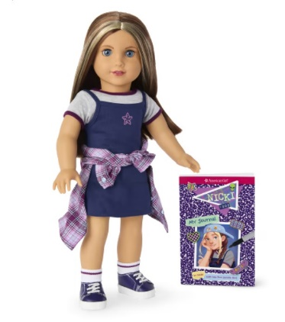

**Nicki: The American Girl Doll** you can take home and return. Nicki Hoffman has blue eyes that open and close, and long straight brown hair with two blonde face-framing highlights. Nicki opens up a whole world of imaginative play and comes with authentic styles from 1999.

**The kit includes:**

* 1 doll named Nicki
* 1 paperback book, *Nicki: My Journal* by Nicki Hoffman (with help from Jennifer Roy)
* [Journal to record the doll’s ongoing adventures](http://www.flickr.com/photos/arlib/sets/72157633394972342/)
* Carrying case with Library barcode
* Gray T-shirt with purple binding
* T-shirt dress with a star graphic on the front
* Plaid flannel shirt
* Pink knit T-shirt
* Wide-leg overalls with silver buckles
* Multicolored puffer vest with a collar and American Girl Today™ Grin Pin
* Underwear
* Ankle socks
* Platform sneakers
* Baseball hat with faux mini American Girl Today™ Grin Pins
* Black oval-shaped sunglasses
* Ribbon necklace with a yin-yang pendant
* Messenger bag with a skate graphic on the front
* Composition-style notebook with artwork on the front
* Pink cotton slip-on sneakers
* Skateboard with a graphic on the bottom and movable wheels
* Brush

**Plush chocolate lab puppy, named Blossom**

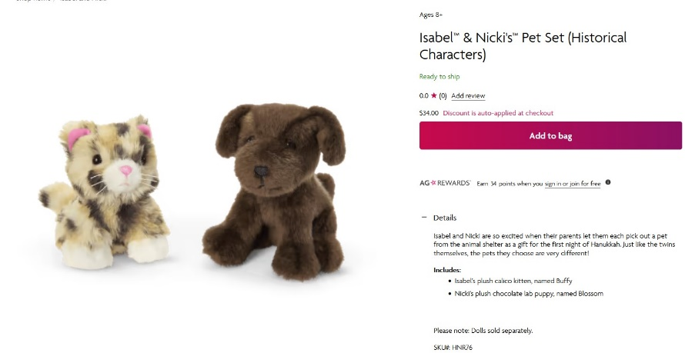Nicki is excited when her parents let her pick out a pet from the animal shelter as a gift for the first night of Hanukkah. She chose a small plush chocolate lab puppy.

* A small plush chocolate lab puppy

**Placing Holds and Borrowing**

**How Do I Borrow this American Girl Doll?**  
Patrons of the Patten Free Library may borrow and place this kit on hold by calling the Children’s Room, 443-5141 x1016. **The doll must go to a smoke-free home.**

**What is the Borrowing Period?**  
You may have the doll kit for **1 week (7 days)**. Please return her on time, so other children will have a chance to take her home.

**Where Do I Return My Doll?**  
Dolls must be returned to the Children’s Room only. Please do not return dolls in the Book Returns. **Doll should be returned in the same condition in which it was received.**

**How Do I Care for a Doll?** **Please do not:** Cut or shampoo hair.

**Parents are responsible for damages or lost items and must assume all costs.**