PFL Color Logo No Tag Patten Free Library, Children's Room, 33 Summer St, Bath, ME 04530, 443-5141 x1016

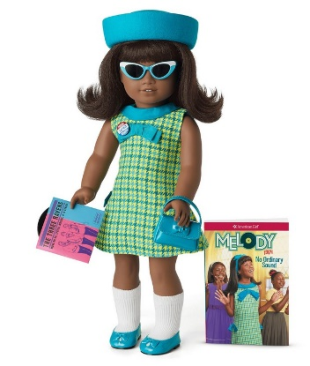

**Melody: The American Girl Doll** you can take home and return. Optimistic Melody Ellison has lifelike deep-brown eyes that open and close smoothly, and realistic thick black hair. She comes in an authentic 1964-style outfit. Melody opens up a whole world of imaginative play and comes with authentic styles from 1964.

**The kit includes:**

* 1 doll named Melody *($100)
* 1 paperback book, *No Ordinary Sound* by Denise Lewis Patrick *($10)
* [Journal to record the doll’s ongoing adventures](http://www.flickr.com/photos/arlib/sets/72157633394972342/) *($10)
* Carrying case with Library barcode *($20)
* A bright blue-and-green hounds-tooth A-line dress with a blue cowl collar, a blue bow on the chest, and blue bows on the side pleats *($25)
* A blue-ribbon headband with a bow for her hair *($10)
* White socks *($10)
* Underwear *($10)
* Shiny blue patent shoes with bows on the toes *($10)
* A felt hat with ribbon trim *($10)
* A patent purse with a bow on the front *($10)
* Cat-eye sunglasses that were popular in the 1960s *($10)
* A Civil Rights campaign button that Melody wears proudly *($10)
* A record and record sleeve featuring The Three Ravens, Melody’s brother’s group! *($10)
* Hairbrush *($10)

**Melody’s Dog, Bo**

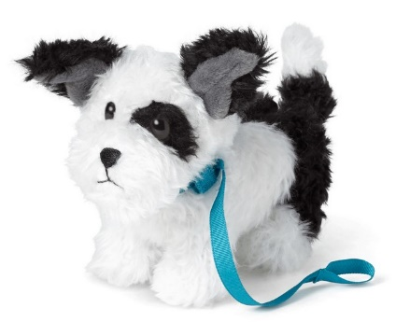

Bo (short for Bojangles) is a cute, scruffy black-and-white dog with one bent ear. He has a warm embroidered mouth and nose, soulful eyes, and a blue collar with a bow that unfolds to become a leash. His set includes:

* A plush black-and-white dog *($24)
* A Blue collar *(10)
* Leash *($10)

**Placing Holds and Borrowing**

**How Do I Borrow this American Girl Doll?**  
Patrons of the Patten Free Library may borrow and place this kit on hold by calling the Children’s Room, 443-5141 x16. **The doll must go to a smoke-free home.**

**What is the Borrowing Period?**  
You may have the doll kit for **1 week (7 days)**. Please return her on time, so other children will have a chance to take her home.

**Where Do I Return My Doll?**  
Dolls must be returned to the Children’s Room only. Please do not return dolls in the Book Returns. **Doll should be returned in the same condition in which it was received.**

**How Do I Care for a Doll?** **Please do:** Brush and style your doll’s hair using the provided doll brush only. **Please do not:** Cut or shampoo hair.

**Parents are responsible for damages or lost items and must assume all costs. Please see itemized list.**