PFL Color Logo No Tag

Patten Free Library, Children's Room, 33 Summer St, Bath, ME 04530, 443-5141 x1016

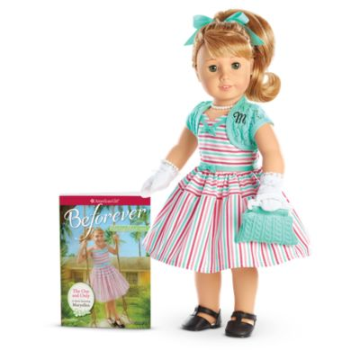

**Maryellen: The American Girl Doll** you can take home and return to the library for one week. Imaginative Maryellen Larkin has hazel eyes that open and close, and her long strawberry-blond hair is worn in a high ponytail with sideswept bangs. She comes in an authentic 1950s outfit.

**The kit includes:**

* 1 doll named Maryellen *($100)
* 1 paperback book, *Beforever Maryellen: The One and Only* by Valerie Tripp *($10)
* [Journal to record the doll’s ongoing adventures](http://www.flickr.com/photos/arlib/sets/72157633394972342/) *($10)
* Carrying case with library barcode *($20)
* A striped dress with a sweetheart neckline, tailored bows, and a full skirt *($25)
* An aqua lacy-knit shrug monogrammed with her initial *($10)
* Black Mary Jane shoes *($10)
* White underwear *($10)
* An aqua ribbon bow on a ponytail holder for her hair *($10)
* An aqua knit pocketbook *($10)
* Pearl necklace *($10)
* Pearl bracelet *($10)
* White gloves *($10)
* Doll brush *($10)

**Placing Holds and Borrowing**

**How Do I Borrow this American Girl Doll?**  
Patrons of the Patten Free Library may borrow and place this kit on hold by calling the Children’s Room, 443-5141 x16. **The doll must go to a smoke-free home.**

**What is the Borrowing Period?**  
You may have the doll kit for **1 week (7 days)**. Please return her on time, so other children will have a chance to take her home.

**Where Do I Return My Doll?**  
Dolls must be returned to the Children’s Room only. Please do not return dolls in the Book Returns. **Doll should be returned in the same condition in which it was received.**

**How Do I Care for a Doll?** **Please do:** Brush and style your doll’s hair using the provided doll brush only. **Please do not:** Cut or shampoo hair.

**Parents are responsible for damages or lost items and must assume all costs. Please see itemized list.**