PFL Color Logo No Tag Patten Free Library, Children's Room, 33 Summer St, Bath, ME 04530, 443-5141 x1016

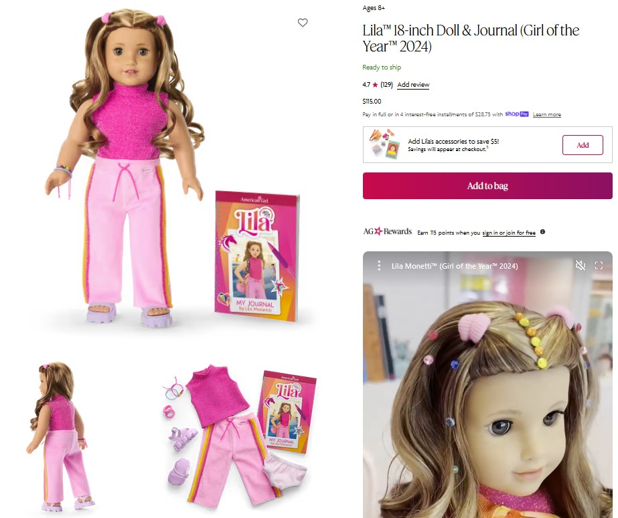

**Lila The American Girl Doll** you can take home and return. As the new girl on her gymnastics squad, Lila wonders if she’s good enough to make the Xcel Gold Team. When she gets the chance to go to horse camp, she finds creative ways to train for gymnastics and forms an unexpected friendship that boosts her confidence. Lila Monetti opens up a whole world of imaginative play.

**The kit includes:**

* 1 doll named Lila
* 1 paperback book, *My Journal by Lila Monetti,* by Lila Monetti (with help from Erin Falligent)
* [Journal to record the doll’s ongoing adventures](http://www.flickr.com/photos/arlib/sets/72157633394972342/)
* Carrying case with Library barcode
* A sparkly pink knit mock turtleneck tank top
* Pale-pink track pants with sparkly striped trim on the sides
* Light-purple platform sandals
* Pair of underwear
* Blue beaded bracelet
* Pink cord bracelet with three multicolored gems
* Two small soft-pink hairbands
* Orange, yellow, and pink marble-print crossbody bag with a front zipper pocket and an orange strap with a buckle closure
* Pretend cell phone with a pink case and a reversible phone screen
* Orange frameless sunglasses
* Booklet filled with hairstyling ideas and instructions
* Button-front denim jacket with multicolored sequined sleeves, a collar, and pocket flaps
* Light-pink knit tee with a colorful horseshoe graphic
* Black leggings
* Pink bow headband
* Sparkly pink riding boots

**Placing Holds and Borrowing**

**How Do I Borrow this American Girl Doll?**  
Patrons of the Patten Free Library may borrow and place this kit on hold by calling the Children’s Room, 443-5141 x1016. **The doll must go to a smoke-free home.**

**What is the Borrowing Period?**  
You may have the doll kit for **1 week (7 days)**. Please return her on time, so other children will have a chance to take her home.

**Where Do I Return My Doll?**  
Dolls must be returned to the Children’s Room only. Please do not return dolls in the Book Returns. **Doll should be returned in the same condition in which it was received.**

**How Do I Care for a Doll?** **Please do:** Style Lila’s hair. We recommend finger styling for best results. To finger style, separate a small section of hair and lightly mist with lukewarm water, then gently work your fingers through it, twirling as you go to create tight curls.

**Please do not:** Cut or shampoo hair. Please do NOT brush Lila’s hair. Please follow above directions for styling.

**Parents are responsible for damages or lost items and must assume all costs.**