PFL Color Logo No Tag Patten Free Library, Children's Room, 33 Summer St, Bath, ME 04530, 443-5141 x1016

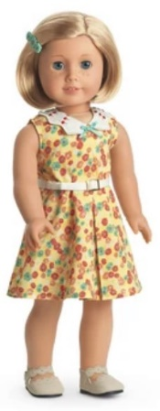

**Kit: The American Girl Doll** you can take home and return. Clever and resourceful, she is happiest climbing trees, playing baseball, and writing news stories. Margaret “Kit” Kittredge opens up a whole world of imaginative play and comes with authentic styles from the Great Depression era.

**The kit includes:**

* 1 doll named Kit
* 1 paperback book, *Meet Kit : an American girl, Book 1* by Valerie Tripp
* [Journal to record the doll’s ongoing adventures](http://www.flickr.com/photos/arlib/sets/72157633394972342/)
* Carrying case with Library barcode
* Sleeveless yellow floral-print dress with white collar
* Faux-suede tan Mary Jane shoes
* White short-sleeved blouse with blue plaid trim
* Pleated blue-plaid jumper with yellow flowers
* Matching removable belt with a white buckle
* White knit knee socks
* Brown oxford shoes
* Tortoiseshell-patterned hair comb
* Sleeveless one-piece pajamas with a white bodice with blue satin trim
* Red ribbon tie-on headband
* Red slippers with red pom-pom accents and red trim
* Black accordion-style camera with black hard shell camera case
* Blue pouch with red strap for notebook and pen. Yellow pocket for pen
* Black flip top journal. "Notes" in gold print at bottom
* Red fountain pen with gold nib and removable cap
* Newspaper of the Cincinnati Register with Kit's story on the front page

**Placing Holds and Borrowing**

**How Do I Borrow this American Girl Doll?**  
Patrons of the Patten Free Library may borrow and place this kit on hold by calling the Children’s Room, 443-5141 x1016. **The doll must go to a smoke-free home.**

**What is the Borrowing Period?**  
You may have the doll kit for **1 week (7 days)**. Please return her on time, so other children will have a chance to take her home.

**Where Do I Return My Doll?**  
Dolls must be returned to the Children’s Room only. Please do not return dolls in the Book Returns. **Doll should be returned in the same condition in which it was received.**

**How Do I Care for a Doll?** **Please do:** Brush and style your doll’s hair using the provided doll brush only. **Please do not:** Cut or shampoo hair.

**Parents are responsible for damages or lost items and must assume all costs.**