PFL Color Logo No Tag Patten Free Library, Children's Room, 33 Summer St, Bath, ME 04530, 443-5141 x1016

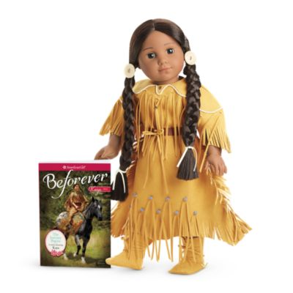

**Kaya: The American Girl Doll** you can take home and return to the library for one week. Daring Kaya has deep-brown eyes that open and close and long, shiny black hair. She comes in an authentic 1764 Nez Perce outfit.

**The kit includes:**

* 1 doll named Kaya *($100)
* 1 paperback book, *Beforever Kaya: The Journey Begins* by Janet Shaw *($10)
* [Journal to record the doll’s ongoing adventures](http://www.flickr.com/photos/arlib/sets/72157633394972342/) *($10)
* Carrying case with library barcode *($20)
* A soft faux-deerskin dress trimmed with fringes, beads, and pretend quillwork, tied with a faux-leather belt *($25)
* Papoose doll inside sideboard (backpack) *($60)
* Matching moccasins with ties *($10)
* A patterned woven bag with handles *($10)
* A smaller woven pouch that attaches to Kaya's belt to hold food and little treasures *($10)
* A brightly colored faux-porcupine-quill necklace *($10)
* Doll brush *($10)

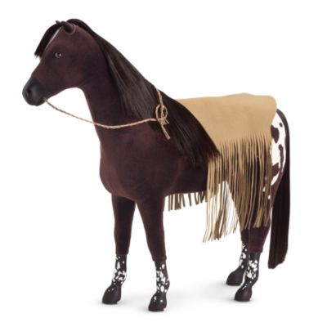

**Kaya's Mare, Steps High**

Kaya is very proud that her beloved horse, Steps High, chose her. She loves training horses with her father and riding Steps High whenever she can. Her set includes:

* A deep brown Appaloosa mare with a white star on her forehead and a black mane and tail *($75)
* A fringed faux hide blanket *($10)
* Carrying bag *($10)

**How Do I Borrow this American Girl Doll?**  
Patrons of the Patten Free Library may borrow and place this kit on hold by calling the Children’s Room, 443-5141 x16. **The doll must go to a smoke-free home.**

**What is the Borrowing Period?**  
You may have the doll kit for **1 week (7 days)**. Please return her on time, so other children will have a chance to take her home.

**Where Do I Return My Doll?**  
Dolls must be returned to the Children’s Room only. Please do not return dolls in the Book Returns. **Doll should be returned in the same condition in which it was received.**

**How Do I Care for a Doll?** **Please do:** Brush and style your doll’s hair using the provided doll brush only. **Please do not:** Cut or shampoo hair.

**Parents are responsible for damages or lost items and must assume all costs. Please see itemized list.**