PFL Color Logo No Tag Patten Free Library, Children's Room, 33 Summer St, Bath, ME 04530, 443-5141 x1016

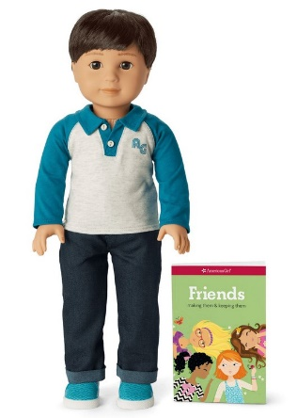**Kai the Guy: The American Girl Doll** you can take home and return. Kai has brown eyes, dark brown hair, and olive skin. Kai opens up a whole world of imaginative play and comes with casual clothing and a soccer outfit.

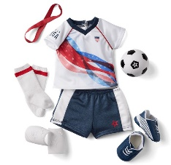

**The kit includes:**

* 1 doll named Kai *($115)
* 1 paperback book, *Friends: making them & keeping them* by Patti Kelley Criswell *($10)
* [Journal to record the doll’s ongoing adventures](http://www.flickr.com/photos/arlib/sets/72157633394972342/) *($10)
* Carrying case with Library barcode *($20)
* A heather-gray collared shirt with contrasting blue sleeves and an AG logo on the chest
* A pair of denim pants
* Briefs
* Multicolored sneakers
* A soccer jersey with a fun stars-and-stripes graphic on the front ($32)
* A pair of blue shorts with a side stripe and star logo
* A headband to keep his hair back
* A pair of socks with red stripes
* A pair of shin guards that clip on under a doll’s socks
* A pair of cleats with stripes on the side
* A foam soccer ball with the American Girl Inner Star logo

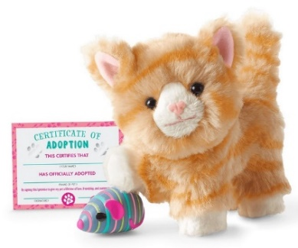**Abby the Tabby Cat**

Every Truly Me™ doll needs a kitty to cuddle up with. This posable orange tabby cat loves to snuggle when she’s not playing with her striped toy mouse, which attaches to her mouth with a magnet. Includes a printed paper adoption certificate. Her set includes:

* An orange tabby cat*($28)
* A magnetic, striped toy mouse *($10)

**Placing Holds and Borrowing**

**How Do I Borrow this American Girl Doll?**  
Patrons of the Patten Free Library may borrow and place this kit on hold by calling the Children’s Room, 443-5141 x1016. **The doll must go to a smoke-free home.**

**What is the Borrowing Period?**  
You may have the doll kit for **1 week (7 days)**. Please return her on time, so other children will have a chance to take her home.

**Where Do I Return My Doll?**  
Dolls must be returned to the Children’s Room only. Please do not return dolls in the Book Returns. **Doll should be returned in the same condition in which it was received.**

**How Do I Care for a Doll?** **Please do:** Brush and style your doll’s hair using the provided doll brush only. **Please do not:** Cut or shampoo hair.

**Parents are responsible for damages or lost items and must assume all costs. Please see itemized list.**