PFL Color Logo No Tag Patten Free Library, Children's Room, 33 Summer St, Bath, ME 04530, 443-5141 x1016

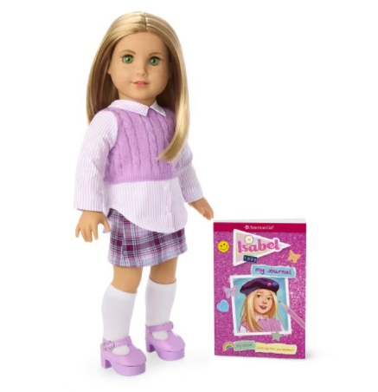

**Isabel: The American Girl Doll** you can take home and return. Isabel Jane Hoffman has green eyes that open and close, and medium-length blonde hair with layers and platinum highlights. Isabel opens up a whole world of imaginative play and comes with authentic styles from 1999.

**The kit includes:**

* 1 doll named Isabel
* 1 paperback book, *Isabel: My Journal* by Isabel Hoffman (with help from Julia DeVillers)
* [Journal to record the doll’s ongoing adventures](http://www.flickr.com/photos/arlib/sets/72157633394972342/)
* Carrying case with Library barcode
* Cropped cable-knit sweater with attached collared shirt
* Plaid skirt
* Knee socks
* Platform shoes
* White cotton underwear
* Felt beret with faux mini American Girl Today™ Grin Pins
* Mini backpack
* Pink sunglasses
* Beaded necklace
* Scrapbook
* Dress with an attached argyle sweater vest with a cotton collar and pleated white tennis skirt
* Pink underwear
* White ankle socks with multicolored stripes
* White tennis shoes
* Tennis racket and a tennis ball
* Purple brush

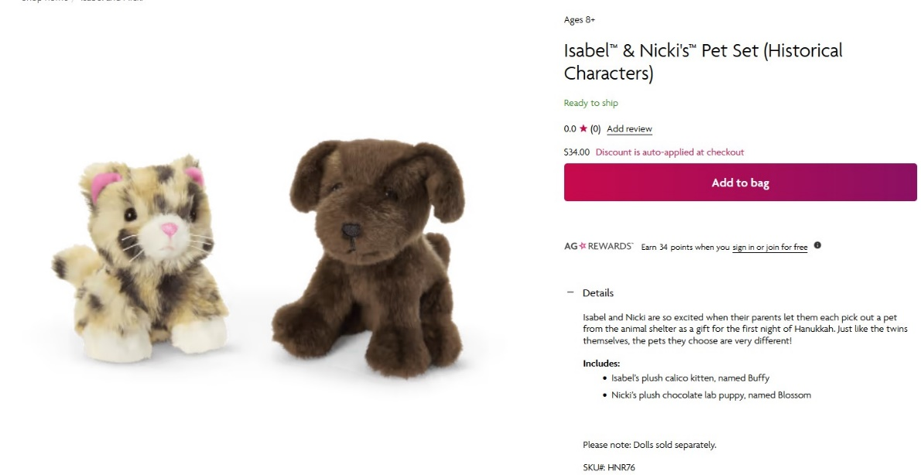**Plush calico kitten, named Buffy**

Isabel is excited when her parents let her pick out a pet from the animal shelter as a gift for the first night of Hanukkah. She chose a plush calico kitty.

* A small plush calico kitty

**Placing Holds and Borrowing**

**How Do I Borrow this American Girl Doll?**  
Patrons of the Patten Free Library may borrow and place this kit on hold by calling the Children’s Room, 443-5141 x1016. **The doll must go to a smoke-free home.**

**What is the Borrowing Period?**  
You may have the doll kit for **1 week (7 days)**. Please return her on time, so other children will have a chance to take her home.

**Where Do I Return My Doll?**  
Dolls must be returned to the Children’s Room only. Please do not return dolls in the Book Returns. **Doll should be returned in the same condition in which it was received.**

**How Do I Care for a Doll?** **Please do not:** Cut or shampoo hair.

**Parents are responsible for damages or lost items and must assume all costs.**