PFL Color Logo No Tag Patten Free Library, Children's Room, 33 Summer St, Bath, ME 04530, 443-5141 x1016

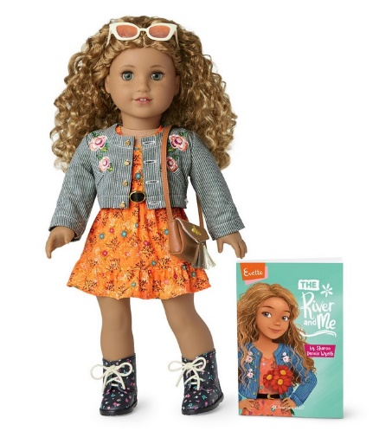

**Evette: The American Girl Doll** you can take home and return. Nature lover Evette Peeters has gray eyes, freckles, and curly caramel-colored hair that comes in a half-up style. Evette opens up a whole world of imaginative play and comes with a fashionable modern style.

**The kit includes:**

* 1 doll named Evette *($100)
* 1 paperback book, *The River and Me* by Sharon Dennis Wyeth *($10)
* [Journal to record the doll’s ongoing adventures](http://www.flickr.com/photos/arlib/sets/72157633394972342/) *($10)
* Carrying case with Library barcode *($20)
* A floral-print dress with crocheted lace at the sleeves *($25)
* White underwear *($10)
* A black belt with a golden buckle *($10)
* A pair of floral-print boots *($10)
* A collarless cropped striped denim jacket with floral embroidery on the front *($20)
* A faux-suede crossbody purse with bumblebee embroidery on the front flap and tassels *($10)
* A pair of retro-inspired cat-eye sunglasses *($10)

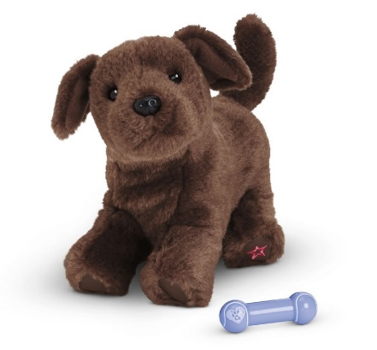**Chocolate lab puppy**

Every doll loves a playful pet—and this sweet chocolate Labrador puppy is an adorable delight! She has soft fur and a body that can be posed in different positions. A magnet in her mouth lets her hold a favorite toy. Her set includes:

* A chocolate brown lab puppy *($28)
* A purple dog toy *($10)

**Placing Holds and Borrowing**

**How Do I Borrow this American Girl Doll?**  
Patrons of the Patten Free Library may borrow and place this kit on hold by calling the Children’s Room, 443-5141 x16. **The doll must go to a smoke-free home.**

**What is the Borrowing Period?**  
You may have the doll kit for **1 week (7 days)**. Please return her on time, so other children will have a chance to take her home.

**Where Do I Return My Doll?**  
Dolls must be returned to the Children’s Room only. Please do not return dolls in the Book Returns. **Doll should be returned in the same condition in which it was received.**

**How Do I Care for a Doll?** **Please do:** Style Evette’s hair. We recommend finger styling for best results. To finger style, separate a small section of hair and lightly mist with lukewarm water, then gently work your fingers through it, twirling as you go to create tight curls.

**Please do not:** Cut or shampoo hair. Please do NOT brush Evette’s hair. Please follow above directions for styling.

**Parents are responsible for damages or lost items and must assume all costs. Please see itemized list.**