PFL Color Logo No Tag Patten Free Library, Children's Room, 33 Summer St, Bath, ME 04530, 443-5141 x1016

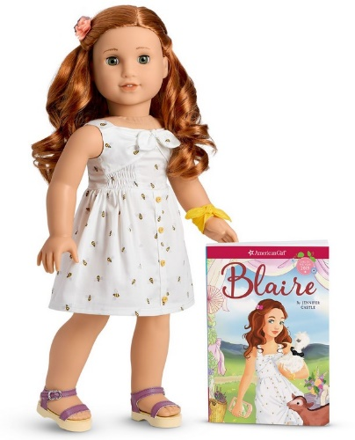

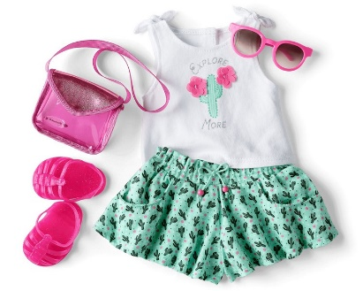

**Blaire: The American Girl Doll** you can take home and return. Blaire Wilson has bright green eyes that open and close, and curly red hair. Blaire opens up a whole world of imaginative play and comes with a fashionable modern style.

**The kit includes:**

* 1 doll named Blaire *($100)
* 1 paperback book, *Blaire* by Jennifer Castle *($10)
* [Journal to record the doll’s ongoing adventures](http://www.flickr.com/photos/arlib/sets/72157633394972342/) *($10)
* Carrying case with Library barcode *($20)
* A dress with a bumblebee print and gathered tie *($20)
* A shoulder-tie tank with an applique “Explore More” graphic *($20)
* Cactus-print shorts with cute pockets and a tie at the waist *($20)
* Pink underwear *($10)
* A sunny yellow bandanna bracelet *($10)
* A hair comb with pink flowers *($10)
* Purple platform sandals *($10)
* Pink jelly-style plastic sandals *($10)
* Pink-framed sunglasses *($10)
* A clear vinyl purse with a glitter flap and long over-the-shoulder strap *($10)
* Hairbrush *($10)

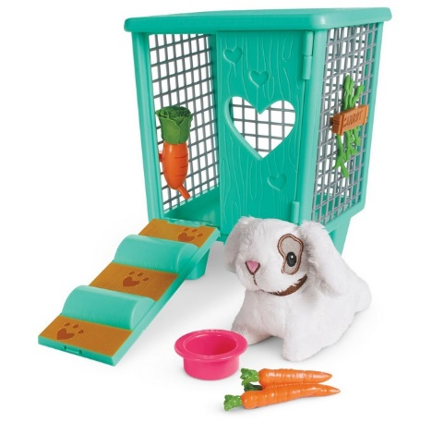**Blaire’s rabbit, Carrot**

Blaire plays with this cute bunny every time she visits the garden! Carrot has a sweet embroidered face and soft fur. Her set includes:

* A white rabbit with brown marking on one eye, and a brown collar *($42)
* A brightly colored hutch with a door that opens into a ramp *($20)
* Carrot’s name sign to hang on the side of the hutch *($10)
* A fun carrot-shaped water dispenser *($10)
* A bundle of pretend carrots with a food bowl *(10)

**Placing Holds and Borrowing**

**How Do I Borrow this American Girl Doll?**  
Patrons of the Patten Free Library may borrow and place this kit on hold by calling the Children’s Room, 443-5141 x16. **The doll must go to a smoke-free home.**

**What is the Borrowing Period?**  
You may have the doll kit for **1 week (7 days)**. Please return her on time, so other children will have a chance to take her home.

**Where Do I Return My Doll?**  
Dolls must be returned to the Children’s Room only. Please do not return dolls in the Book Returns. **Doll should be returned in the same condition in which it was received.**

**How Do I Care for a Doll?** **Please do:** Brush and style your doll’s hair using the provided doll brush only. **Please do not:** Cut or shampoo hair.

**Parents are responsible for damages or lost items and must assume all costs. Please see itemized list.**